Argand Diagram

A complex number can be represented on an Argand diagram by a directed line segment (vector). The x axis is the real axis, and the y axis is the imaginary axis

Example

On an Argand diagram draw the vectors 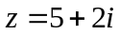 and 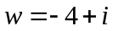. Now draw in vectors representing:

(a) 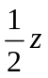

(b)

(c) 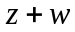

(d)

(e) 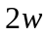

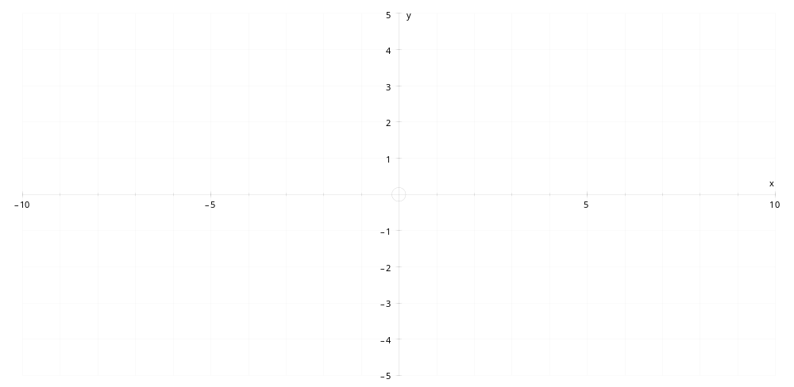
Modulus and argument of a complex number

The modulus of a complex number, written 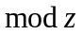or 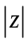 and given the symbol r, is the length of the vector.

The argument of the complex number, written 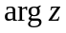 and given the symbol , is the angle between the positive x axis and the vector (given in radians as an angle between and )

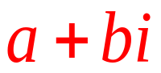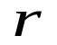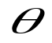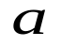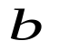
We can see that 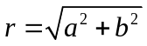 and, in the first quadrant, 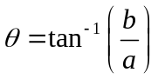.
If we are in a different quadrant, then we must be a little more careful about finding the argument

Example

Find the modulus and argument of the complex number 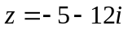

Question

Find the modulus and argument of the complex number 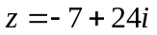

Modulus-Argument form of a complex number

We can see that 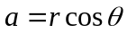 and 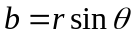
Therefore the complex number 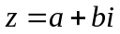 can be written as 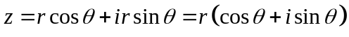
This is called the modulus-argument form of the complex number

Example

- Write the complex number 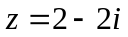 in modulus-argument form

- Write the complex number 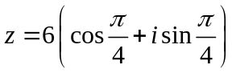 in form

Question

- Write the complex number 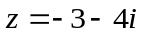 in modulus-argument form

- Write the complex number 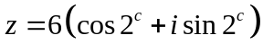 in form to 1 decimal place

Multiplying and Dividing Complex Numbers

When you multiply two complex numbers, the modulus of the answer is the product of the two moduli:

Similarly, when you divide two complex numbers:
Example

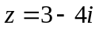 and 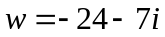

Find:
(a)

(b) 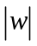

(c) 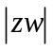

(d) 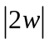

(e) 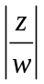

(f) 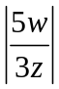

Question

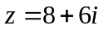 and 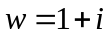

Find in surd form:
(a)

(b)

(c)

(e) 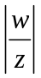

(f) 